ciper ; lmdm jv yffuog hpqppxx

hint : code 392Hz

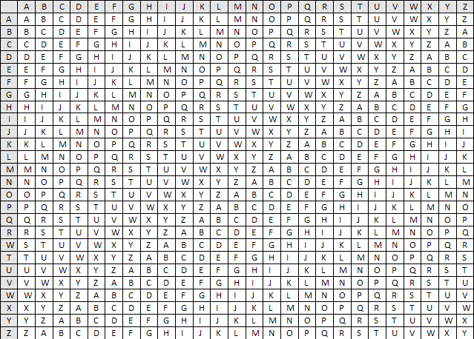

answer: flag is second bonjour